Title (lower case, Calibri, bold, 14 pt, centred)
Authors (bold, 10 pt, centred). Example: A. Oliveira (1), S. Moreira (2) e J. Duarte (3)
- Affiliation (institution, city, country) and e-mail address of the first author
- Affiliation (institution, city, country) of the second author
- …
Abstract: English abstract with a maximum of 150 words in Calibri font, size 10 pt and justified text. The inner and outer margins of the section between the title and keywords must be 3.5 cm and 3.0 cm, respectively.
Keywords: word 1, word 2, word 3, word 4, word 5

1. GUIDELINES
Extended abstracts may be written in Portuguese, Spanish, or English.
Documents must be in Word format and submitted via the EasyChair platform (the file size must not exceed 50 MB) by 20 April 2026.
Submissions will be subject to prior scientific evaluation by a panel of experts, who may propose minor modifications, major changes, or even reject them if the scientific quality is considered insufficient.
Failure to comply with the publication guidelines may also be grounds for rejection.
Papers must have a maximum of four pages, including figures, tables, references, and acknowledgements. Pages must be in A4 format, with mirrored margins: 2 cm top, bottom, and outer margins, and a 2.5 cm inner margin.
The body text must be written in Calibri font, 10 pt size, formatted in two columns of 7.75 cm each, with single line spacing and 5 pt spacing before each paragraph.
Chapter and subchapter titles must be numbered. Chapter titles should be in uppercase, bold, 11 pt, while subchapter titles should be in lowercase, bold, 10 pt. A spacing of 10 pt should be applied before each title.

1.1. Figures e and tables
Figures may be in color (or black and white) and must fit the width of one or two columns. In the text, references to figures should be written in full (e.g., “… in Figure 1” or “… (Figure 1)”).
The text included in each figure must be of an appropriate size to be legible when printed on A4 paper (100% zoom).

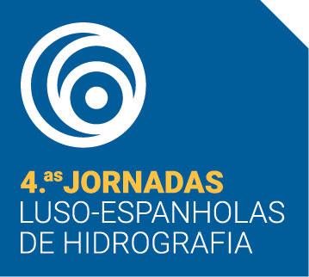
Figure 1. Figure captions (maps, diagrams, photographs, etc.) should be written in italics, 8 pt font, with justified alignment.
Tables must be numbered independently using Roman numerals (Table I, Table II, etc.). The table caption should be placed above the respective table. Regarding text formatting and width, the same rules as for figures apply.
Acknowledgments (if aplicable)
The title of this section should be written in lowercase, bold, 11 pt.

ReferENCES
Citations and bibliographic references must follow the APA (American Psychological Association) style, 7th edition.
The reference list should be placed at the end of the text, in alphabetical order by the first author, with all authors identified.
References must be written in Calibri font, 9 pt size, with 3 pt spacing before each entry and a hanging indent of 0.5 pt.
Examples:
McLane, M. (1995). Sedimentology. Oxford University Press, New York, 423 p.
Santos, A.I., Oliveira, A., Carinhas, D., Pinto, J.P., Zacarias, N. e Freitas, M.C. (2020). The acoustic properties of in-situ measured suspended sediments and their implications on concurrent ADCP response – Case studies of the Portuguese inner shelf. Marine Geology, 419:106079.
Short, A.D. e Masselink, G. (1999). Embayed and Struturally Controlled Beaches. In: Short, A.D. (ed.), Handbook of beach and shoreface morphodynamics. John Wiley & Sons, Chichester, pp. 230-250.
Vinhas, A. e Rodrigues, A (2023). A cobertura sedimentar da plataforma continental do barlavento algarvio: análise sismo-estratigráfica e evolução recente. Livro de resumos do XI Congresso Nacional de Geologia, Coimbra, pp. 173-174.

